AM310 – Instrumentation and Theory of Experiments

The Wheatstone Bridge and Strain Measurement

Concepts: Wheatstone bridge, Linearity, Strain gage, Stresses in cantilever beams, Compensation, Micrometers, Dual Sensitivity

- Introduction

The Wheatstone bridge circuit is used very commonly in instrumentation for the comparison and measurement of resistances. In particular, this circuit is used very often in conjunction with strain-gage based transducers, e.g. basic electrical resistance strain gages, load cells and pressure transducers. The Wheatstone bridge circuit is also employed in other applications such as thermistor thermometry and hot wire/film anemometry.

The strain gage is a transducer which is sensitive to strain. The “electrical resistance stain gage” consists of a thin filament with a known resistance that is bonded to a structural element whose strain is to be measured. When a strain is sensed by the gage, its resistance changes by a small amount (of the order of 0.1%).

The Wheatstone bridge and the “electrical resistance strain gage” form an excellent combination with the small change in resistance being detected by the Wheatstone bridge. In the “deflection mode” of the bridge, we can obtain a voltage output which is linearly proportional to the resistance change caused by the strain.

In practice, however, this voltage is rather small (on the order of millivolts) and it is necessary to amplify the output to yield a signal that is more easily measured. It should be noted that this is one reason bridge circuits are preferred over voltage divider circuits for detecting small changes in resistance. The bridge circuit can be balanced before measurements are made so that only the voltage produced by the change in resistance during the measurement is amplified in the amplifier. Voltage divider circuits produce large DC offsets in their output signals, in addition to small voltage changes during measurement. The large DC offset from a voltage divider circuit can saturate the amplifier, thus rendering the measurement system useless.

Although in principle, the amplifier could be a single operational amplifier circuit, a single op amp cannot be used in practice because it cannot provide sufficient gain, therefore so the two-stage differential amplifier you tested in the previous lab will be used.

In this experiment you will first study a simple Wheatstone bridge and then measure strain in a cantilever beam by building the basic elements of a strain indicator – Wheatstone bridge and amplifier. In fact, considering the cantilever as a transducer for converting force applied to its tip to strain long its length, you will have built an entire force measuring system similar to one used in the wind tunnel experiments.

- Theory

  - Wheatstone Bridge Circuit

There are two ways of using the Wheatstone Bridge: as a null bridge or as a deflection bridge. In this lab you will use it as a deflection bridge. To learn more about using the Wheatstone bridge as a null bridge, see the sources listed in the ‘additional reading’ section of this lab. The deflection bridge consists of four resistors arranged as in Figure 1. An external power supply voltage (“excitation”) E is applied across terminals B and D. The input to the circuit is considered a change in the resistance of the resistors while the output signal is the resulting voltage drop (due to the change in resistance) measured across terminals A and C, E_{AC}.

V
A
B
C
D
R₁
R₃
R₂
R₄
E
Figure 1: Simple Wheatstone bridge circuit

To use the deflection bridge as described above, you need to relate the change of resistance to the change in voltage from the initial state to the final state. A convenient initial state is for the E_{AC} to be equal to zero; when E_{AC} is zero, the bridge is said to be balanced. When the bridge is balanced, it can be shown that

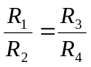 (1)

After balancing the circuit, if the resistance of one of the resistors is changed from its initial setting, the voltage E_{AC} will change, thus a change in the resistance can be detected by a change in the voltage. Since E_{AC} is initially equal to zero, the change in E_{AC} (ΔE_{AC}) equals E_{AC} (i.e. ΔE_{AC} = E_{AC} - E_{AC initial} = E_{AC} – 0 = E_{AC} ). Let R₁ be the resistance that changes. Define its initial value as R₁₀ and the change to be ΔR₁. If a very high impedance meter is used for measurement of E_{AC}, it can be shown that:

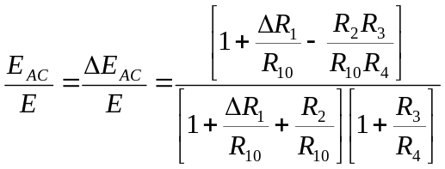 (2)

But using Equation 1 this can be reduced to:

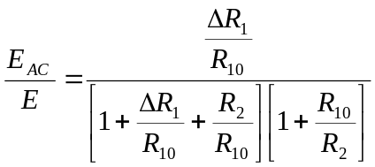 (3)

if R₁₀ = R₂ = R₃ = R₄, i.e. all resistances were initially the same,

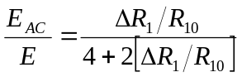 (4)

Although the voltage E_{AC} is not strictly linear with respect to ΔR₁/R₁₀, for values of 2ΔR₁/R₁₀ negligible to compared to 4 (i.e., ΔR₁/R₁₀ << 2) this nonlinearity will not affect the value of the denominator to an appreciable extent. For ΔR₁/R₁₀ << 2, the denominator is essentially equal to 4, so E_{AC} / E is essentially linearly proportional to ΔR₁/R₁₀. This property of the deflection bridge is often utilized in instrumentation applications. The linear approximation for the bridge response with all resistors equal at initial balance is thus:

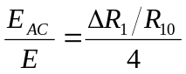 (5)

  - Electrical Resistance Stain Gage

The “electrical resistance stain gage” consists of a thin filament with a known resistance that is bonded to a structural element whose strain is to be measured. When the structure undergoes strain, the resistance of the gage changes – it increases for elongation and decreases for compression – by a small amount (provided there are no changes in the temperature of the gage).

Equation 6 states that: the fractional change in resistance of the strain gage is a function of the mechanical strain, the Poisson ratio of the strain gage material and the temperature of the strain gage.

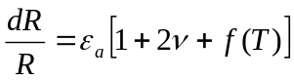 (6)

Where:

dR = small change in resistance
R = unstrained resistance of strain gage
ε_{a} = strain along the primary axial direction
ν = Poisson ratio of stain gage material
f (T) = Temperature dependent terms

It is usual practice to define a gage factor F by

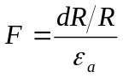 (7)

so that F takes the place of all the terms in the square bracket in Equation 5. Therefore, for small, but finite changes of resistance,

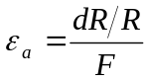 (8)

The value of F is a property of the gage material and is given by the manufacturer or can be found from calibration. Thus, by measuring ΔR/R and knowing F, the strain ε_{a} can be found.

  - Using the Strain Gages with the Wheatstone Bridge

The Wheatstone bridge can be used as a means of determining ΔR/R to find the strain ε_{a}. In this arrangement, the strain gage would replace resistor R₁ in the circuit of Figure 1. The ΔR₁/R₁₀ values due to strain are typically of the order of 1.0x10⁻⁸ and hence we can assume from Equation 4:

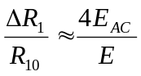 (9)

provided R₁₀ = R₂ = R₃ = R₄. Therefore,

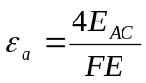 (10)

Recall from the previous section that changes in temperature also affects the resistance of the strain gage; this property of the strain gage is called “dual sensitivity.” In fact, the change in the resistance of a strain gage due to changes in temperature is actually comparable to the changes produced by the mechanical strain itself. Therefore a practical problem associated with using strain gages is how to account for this temperature dependence. The problem can be overcome if the arrangement of the bridge circuit is modified to that of Figure 2 to include a second stain gage which maintained at the same temperature as the first gage. The first gage is known as the active gage, and the second gage is called a compensation gage. It can be shown (do so in your pre-lab) for identical strain gages in the adjacent arms 1 and 2 (as in Figure 2) that

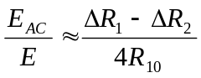, (11)

where ΔR₁ and ΔR₂ are changes in R₁ and R₂ from their values at initial balance. ΔR₁ is due to two causes: mechanical strain change and temperature change. ΔR₂ is due only to temperature changes. Let ΔR_{S (1,2)} and R_{T(1,2)} be the changes in resistance due to mechanical strain and temperature respectively, with the subscript numerals standing for strain gage 1, and strain gage 2. For the configuration in Figure 2, ΔR_{S2} ≡ 0 (because there is no stress placed on it) and ΔR_{T1} = ΔR_{T2} (because the strain gages are identical). Thus Equation 10 becomes

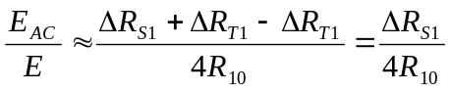 (12)

and Equation 9 holds independent of temperature changes. This is called “temperature compensation,” and is another reason why bridge circuits are preferred over voltage divider circuits in many applications – there is no way to do temperature compensation with a voltage divider.

R₂
E
Gage 2
Specimen
R₃
R₃
Gage 1

R₁

Compensation
Gage
R_{g}
Figure 2: Temperature compensation arrangement for electrical resistance strain gages

A different arrangement of strain gages can also accomplish temperature compensation, and it can also increase the sensitivity of the measurement. Instead of using a strain gage mounted on a separate (non-strained structural element) as the compensation gage, it can be mounted on the opposite side of the strained element. This arrangement means that the two strain gages will be subject to equal, but opposite strains, (i.e. one will be in tension and the other compression), and additionally they will still be subject to the same temperature changes. Let ΔR_{S1} = ΔR_{S2} and ΔR_{T1} = ΔR_{T2}. Thus, Equation 10 becomes

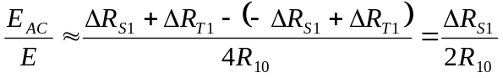 (13)

And thus, Equation 9 becomes

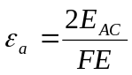 (14)

The arrangement with only one gage sensing strain is called a “quarter bridge,” since only one quarter (one arm) of the bridge is participating in the active measurement. The other arrangement, with both gages sensing the mechanical strain is called a “half bridge.”

  - Theoretical Deflection and Strain of a Cantilever

The following derivation relates the load “P,” deflection “y” and stain “ε_{a}” for a cantilever beam. See Figures 3 and 4.

Figure 3: Geometric quantities used in deflection derivation
y
x
Micrometer
a
m
P
L
Beam Cross Section
h
b

Clamp
Micrometer
Cantilever
Beam

Strain Gage Element
Deflection Gage
Loading
Hook

Base
Figure 4: Schematic of cantilever beam and loading device

To find the deflection y at position x on the beam, Equation 15 must be solved using appropriate boundary conditions.

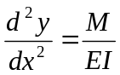 (15)

in which 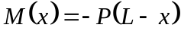 is the moment at a position x due to load P. The boundary conditions at x = 0 are 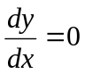 and y = 0. y(x) can be found by integrating Equation 15 twice and applying the boundary conditions.

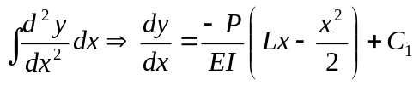, C1 found from boundary conditions.

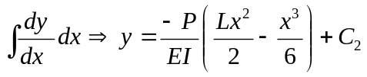, C2 found from boundary conditions.

At the end of the beam, x = L the defection is:

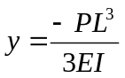.

At the center of the micrometer, x = m, the deflection is

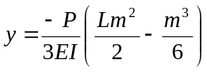.

At the center of the stain gage, x = a, the strain is

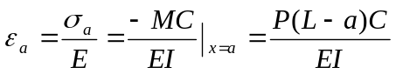,

where σ_{a} is the stress producing the strain, and E Is the Young’s modulus of the material of the beam.

- Procedure

The experiment consists of five parts. In the first part, a Wheatstone bridge circuit with known resistors is balanced using a decade resistance box (DRB) as the variable resistance. In the second part the DRB is used to study the Wheatstone bridge as a deflection bridge by measuring the output voltage variation for changes in the resistance of the DRB. In the three remaining parts, strain in a cantilever beam is measured with electrical resistance strain gages, utilizing the quarter bridge and half bridge configurations.

NOTE: You will need your differential amplifier from the previous lab. Obtain it from the TF.

  - Balancing the Bridge

Set up a circuit as in Figure 1 with R₂ = R₃ ₌ R₄ = 10 kΩ. Use a DRB in place of R₁. Use a DC power supply to supply E and set it to 15.0 V. Use a multimeter to measure E_{AC}.

Before building the circuit, measure and record the values of the individual resistors using the multimeter. You cannot measure the resistance of the individual components when they are parts of the bridge. Why not? You should keep track of specific values of R₂, R₃, and R₄. Next, balance the bridge by changing the resistance of R₁ (by flipping the appropriate switches on the DRB). Recall from the first lab that you cannot trust the resistance indicated on the decade resistance box: be sure to measure the resistance of the DRB that results in balancing the circuit!

SPOT CHECK: Make sure that the value of resistance required for balancing the bridge is reasonable by comparing it to the value predicted by theory (i.e. use Equation 1 with the measured values of R₂, R₃, and R₄ to solve for R₁).

  - Deflection Bridge

Starting with the bridge balanced, (i.e., E_{AC} = 0), decrease the resistance on the decade box in steps of 20Ω (i.e. 20Ω less than the resistance on the decade box necessary to balance the bridge) to a total decrease of 100 Ω, then in steps of 100Ω to 500Ω, and then in steps of 500Ω to 3000Ω. Again, be sure to measure the resistance of the decade resistance box for each step, instead of trusting the settings on the box itself. Record the output, E_{AC}, for each step, noting the sign. Balance the bridge before continuing. Next, increase the resistance by the same steps as before and record the output, again noting the sign.

  - Longitudinal strain in a Cantilever – Quarter Bridge

There are two aluminum section provided – the first is fixed in a loading device as a cantilever beam while the second is not mounted. The first section has two strain gages mounted on it, one on the top surface and one on the bottom surface directly below the former. Both gages have their elements oriented along the longitudinal axis of the beam.

Make sure to take all the dimension measurements on the loading device which are needed for theory, see Figures 3 and 4. BE VERY CAREFUL WHEN HANDLING THE STRAIN GAGES, SINCE STRAIN GAGES AND CONNECTING WIRES ARE VERY DELICATE!

Build a quarter bridge Wheatstone bridge circuit on the breadboard as shown in Figure 5. Connect the longitudinal strain gage on the upper surface of the cantilever beam in place of the active gage and the gage mounted on the unloaded bar in place of the compensation gage. Use a precision resistor for R₃ (121Ω) and a potentiometer (200 Ohm) in place of R₄. Apply a bridge excitation of 5.0 volts (from the DC power supply).

V
Bridge
Output
E_{AC}
Compensation gage
R₂
R₄
E =5 V
Active gage
on top
200Ω
pot.
121Ω

Figure 5: Quarter-bridge circuit

Next, connect the output of the bridge circuit to the input of your differential amplifier. First, however, check that the amplifier is working properly. Turn the power on only after rechecking that the circuit is correctly set up.

You will need to measure the output of the bridge and the output of the amplifier; use the front and rear connections on the multimeter to accomplish this. Measure the un-amplified voltage E_{AC} (i.e. the output of the bridge) with no load applied to the cantilever beam (be sure that the micrometer on the loading device is not deflecting the beam). Adjust the variable resistor R₄ until the amplified signal becomes zero (or as close as you can manage). Record the value of the amplified signal. Also record the amplifier output, this is a zero offset. If the output signals are very noisy, it is possible that the pot R₄ is defective or dirty; try another pot. Load the cantilever beam with 200 grams. Measure the outputs of the bridge and amplifier and record these values. The change in amplifier output should be roughly 100 times the change in the Wheatstone bridge output.

SPOT CHECK: Calculate and compare theoretical and experimental strain values for the 200 gram load before proceeding. Note that you will have to know the Young’s Modulus for aluminum.

If you come this far, you have built the “stain indictor” satisfactorily. You can now start taking data.

Unload the cantilever beam and recheck and record the zero-offsets.

Increase the load by 20 grams. Record the strain indicator outputs, (both amplified and unamplified). Unload the cantilever and recheck and record the zero offsets.

Repeat the steps until the applied load is 200 grams. Recheck and record zero readings each time you change the load.

If the outputs are unstable, you should make multiple measurements, both loaded and unloaded, at each value of loading so you will have sufficient data to determine a mean value, and a precision uncertainty in ΔE_{AC}.

  - Longitudinal Strain – Half Bridge

Turn off the power supply to the Wheatstone bridge and reconfigure the bridge into a half bridge as shown in Figure 6 by replacing the compensating gage mounted on the non-strained beam by the gage on the lower side of the mounted beam. Readjust the potentiometer (R₄) until the bridge is balanced. Record the amplifier and bridge output.

V
Bridge
Output
E_{AC}
Active gage
on bottom
R₂
R₄
E =5 V
Active gage
on top
200Ω
pot.
121Ω

Figure 6: Half-bridge Circuit

Apply loads of 20 grams to 200 grams to the cantilever beam as before and measure the strain indicator outputs (both amplified and un-amplified, both loaded and unloaded for each load).

  - Beam Deflection

With the beam unloaded, rotate the micrometer clockwise until it touches the beam surface very lightly (you can use the output of your strain indicator to help you with this). Record the micrometer reading. For each of the loads used in the strain measurement sections, measure and record the beam’s deflection using the micrometer.

Unload the beam and turn the micrometer head counter-clockwise until the deflection gage no longer makes contact with the beam surface.

- Results and Discussion

1. For the deflection bridge, plot the measured ratio E_{AC} /E as a function of ΔR₁ / R₁₀. Is it linear? Discuss this curve. Use two graphs for this part, one with ΔR₁ between -100 ohms and 100 ohms and another with ΔR₁ between -3000 ohms and +3000 ohms. In addition to the measured data, plot the non-linear and linear theories (Equations 4 and 5, respectively).

2. What is the input range for a linearity error of less that 1%? Determine it both from theory and from your experimental data.

3. Given the gage factor F=2.02, calculate the horizontal strains for the different loads from the strain indicator outputs (for the quarter bridge and half bridge, both un-amplified and amplified). Don’t forget to include the amplifier gain in your calculations.

4. Compare the longitudinal stain obtained during the experiment with the theoretical values expected. Also compare the measured defections with the theoretical values.

- Additional Reading

Dally, James W., William F. Riley, and Kenneth G. McConnell. Instrumentation for
Engineering Measurements. 2nd ed. John Wiley & Sons, 1992. Pgs: 85-91, 131, 135, 192-238.

Beckwith, Thomas G., N. Lewis Buck, and Roy D. Marangoni. Mechanical
Measurements. Reading, Massachusetts: Addison-Wesley, 1982. Pgs: 134-143, 353-397.

Holman, Jack P. Experimental Methods for Engineers New York: McGraw-Hill, 1971.
Pgs: 110-117, 362-370

Figliola, Richard S. and Donald E. Beasley. Theory and Design for Mechanical
Measurements. 2nd ed. New York: Wiley, 1995. Sections 6.5, and 11.3-11.5.

- Authors

Written by Dr. Bala Bharadvaj (Oct. 1982)
Revised by Dr. Bala Bharadvaj (Oct. 1984)
Revised by Dr. Mort Isaacson and Mr. Frank Kuhn (Feb. 1985)
Revised by Dr. Mort Isaacson and Mr. Mike D’Angelo (Jan. 1987)
Revised by Dr. Mort Isaacson (Apr. 1992)
Revised by C. Thomas and Dr. R.G. Holt

